**PROACTIVE DISASTER MANAGEMENT FOR FIRE HAZARDS**

Shreejeswini R Kolekar1, Sahana R Prasad2, Thanu Shree M3, Ananya B R4 , Dr. G. Vennira Selvi5

School of Computer Science and Engineering

Presidency University, Bangalore, India

***Abstract*—** The devastation cost and damage to life by fire risk is very high thus detection of the fire at early stage with appropriate response system will save both property and live. The system presented in this paper is designed around Arduino that uses a proactive disaster management approach to fire hazards and incorporates improvements on the existing detection, alerting, and response echanisms for Fredo Fire. The system uses a variety of sensors, including flame, smoke and temperature sensors to detect in real-time any conditions that could lead to fire. If detection made, the arduino based system triggered an alarming sound and sends immediately alerts to emergency contact or monitoring person through SMS for internet notification using wireless modules (L298 Motor driver(coverts 12v to 5v, GSM Module)Flame Sensors. The system can also be used to activate external devices such as sprinklers by utilization of relay modules in order for the entire response to an event is handled autonomously. Whether in a place of business, mall or schoolhouse, the system is designed for accuracy and reliability with built-in calibration protocols help reduce nuisance alarms to ensure timely warnings are effective. The fire hazard management system proposed is cost effective, scalable and since it operates autonomously in realtime using Arduino hardware many of the devices such as homes/offices/industries can adapt to this kind of system with ease. The autonomously identifies fire hazards, determines their location, and puts them out with little human intervention. It also sends messages, including the GPS coordinate of the fire, which can be received through SMS or cloud services, allowing quick response and decision-making. This combination of IoT, robotics, and real-time communication provides a strong, scalable solution to overcome fire hazards in residential, industrial, and outdoor environments at an economical price. By providing prompt, preventative resolution coupled with gear detection and high-expediency interaction between control centers and decentralized divers, this groundbreaking paradigm ensures improved fire safety by minimizing the potential for destructive harm.

***Keywords—*** Robot; Arduino,L298N2; Proteus; Fire Extinguisher Hazards

## I.INTRODUCTION

Fire hazards is one of the most destructive emergency which endangers human life, property and nature. One of the most important problems is managing fire hazards, especially in buildings, property solutions – see industrial equipment or other necessities to extinguish smoke spread where conventional firefighting methods can be slow and ineffective. The rising occurrence of incidents related to fire raises the need for modern, autonomous, and reliable systems that can identify and act upon the high risk associated with fires as quickly as possible. Merging of automation, Internet of Things (IoT), and robotics could be a good solution for this problem.

So this project focuses on the idea of Developing Protective Fire Hazard provisions System in which Arduino works as a central controller. It autonomously detects, combates, and extinguishes fire while continuously briefing other stakeholders about the event. The system combines multiple domain-specific module —Flame Sensor Module, Navigation Module, Extinguishing Mechanism Module and Communication Module(GSMSIM900A)— which provides a complete and effective solution to fire hazard.

Flame sensor is a vital safety device that detects if there is a flame present in your heating system, like furnaces or boilers. Its main function is to ensure that fuel is supplied not before but during the flame, so as to avoid an accumulation of unburned fuel and create dangerous situations [1].

After all, flame sensors work by tracking ultraviolet (UV) light from the burning of ionized particles in a fire or infrared radiation that has been converted into electrical energy so it can be kept track on and off. If that flame is not present, the sensor detects such a happening and sends a signal to kill fuel flow so there are no explosions or gas leaks.

Navigation Module: This module is a core component as it directs the system to the location of fire. With a pathfinding algorithm, it guarantees that the system is capable of moving through the space without hitting an object, reaching the source of the threat [2]. The module includes a GPS unit for real-time localization, enabling operation in the global field planning algorithm under challenging and dynamic conditions.

After detecting and locating the fire, Extinguishing Mechanism Module gets activated. This is made up of actuators, a fluid delivery system (like pumps for water or dispensers for CO₂), and direction controls that are driven by servos. This enables localized and effective fire suppression mechanism, which actually prevents the fire spread while saving resources.

Communication Module: When integrated with communication tools, the system allows communicating with stakeholders in real-time. Using L298N Operates 900/1800 MZ of bands for end uses for Wi-Fi, GSM module for SMS alert & GPS module, this module keeps updating the fire location and status to the nearby people or emergency services very accurately. This is especially important for remote or unmanned regions, without human monitoring in case of failure.

We propose a system that utilizes Arduino because it is inexpensive, highly flexible and it can be easily combined with other sensors and modules. With IoT features, real-time monitoring, and autonomous navigation this system is a scalable solution that can be applied in many fire safety applications. The system will, therefore, uncover and minimize risk by combining detection speed, a focused reaction and effective communication to achieve lower response times and damage while increasing safety.

In brief, this project encompass a holistic fire hazard management system with integration of diverse advanced technologies. The groundbreaking development promises to change the way fire safety is practiced, offering an effective and affordable solution to a critical safety challenge of our times.

The losses in terms of life, property, and livelihoods, not to mention the ecological degradation wrought by fires, may be catastrophic as wildfires and fires in urban areas become larger and more frequent. There is an increased frequency of wildfires in areas such as California, Australia, and some parts of the Mediterranean, particularly over the last 30 to 40 years (due to higher temperatures, drought, and availability of dry vegetation). And this becomes a recipe for disaster in urban settings, especially at places where thousands of humans are within a distance from such poorly engineered structures with inadequate regulation, and almost no chance to call the fire engines and evacuate before it reaches catastrophic levels.

Fire management needs a proactive whole-of-government, whole-of-economy, and community approach that encompasses urban planning, emergency services, environmental protection, and land use [3].

With the increasing frequency and intensity of wildfires and fires in urban areas, the consequences of inadequate fire management can be devastating—resulting in the loss of life, property, and livelihoods, as well as significant environmental damage [4]. For instance, in regions like California, Australia, and parts of the Mediterranean, the occurrence of wildfires has escalated in recent decades, exacerbated by factors like higher temperatures, prolonged droughts, and dry vegetation. In urban environments, the risks posed by fires in densely populated areas with poorly regulated infrastructure, coupled with the challenge of quick evacuation, can lead to catastrophic outcomes.

Proactive fire management requires a holistic approach that integrates various sectors, including urban planning, emergency services, environmental conservation, and community involvement. Key components of proactive fire management include:

**Risk Assessment & Early Warning Systems:** It is important to determine high-risk areas and study the fire hazard potential. Fire prediction models, satellite observations, and other real-time monitoring tools forecast and track the spread of fire behavior while allowing authorities to take precautionary actions before an event occurs.

**Fire-Resistant Buildings and Infrastructure:** A combination of retrofitting features into older structures with fire-resistant or non-combustible materials, along with the introduction of stringent fire-resistant building codes in new developments, would provide a robust first line of defense against extreme fire events. When lawfully enforced, these regulations guarantee resilience in new buildings.

**Vegetation Management:** In fire-prone areas, dry vegetation often increases risk. Clearing up dead or dry shrubbery and creating firebreaks (barriers devoid of fuel) around vulnerable areas helps stabilize the situation and prevent the fire from spreading.

**Education and Public Awareness:** Raising awareness among the public regarding fire prevention, preparing for emergencies, and creating defensible spaces around homes is critical. Community engagement programs and training ensure people understand how they can minimize fire risks.

**Innovation and Technology:** Modern emerging technology in fire detection, monitoring, and communication is key to proactive fire management [5]. With the support of drones, remote sensors, and AI-assisted predictive tools, it becomes easier to identify fire threats quickly so that countermeasures can be deployed to contain them before they spread.

**Collaborative Response Plans and Policy Frameworks:** Managing fires requires collaboration among government agencies, local authorities, fire departments, and community organizations. Maintaining updated and well-monitored policies and guidelines is effective in reducing risk, and preparation is essential as no one can predict the future [6].

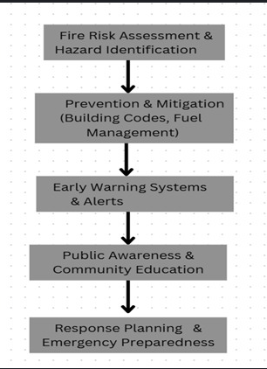

Figure 1. Fire Risk Management Framework

**Fire Risk Assessment & Hazard Identification:** Identify and assess areas vulnerable to fire, considering environmental, infrastructural, and social factors.

**Prevention & Mitigation**: Enforce fire prevention measures, including fire-resistant building codes, fuel management (e.g., clearing vegetation), and other proactive strategies.

**Early Warning Systems & Alerts:** Leverage technology to detect fires early and provide timely alerts to authorities and the public.

**Public Awareness & Community Education** Educate individuals and communities about fire safety, prevention measures, and emergency preparedness.

**Response Planning & Emergency Preparedness** Formulate detailed plans for firefighting, evacuation, and effective post-disaster recovery.

This concise figure 1 and explanation outline the essential stages of proactive fire hazard management, emphasizing a step-by-step approach that builds on each phase to minimize risks and enhance community resilience.

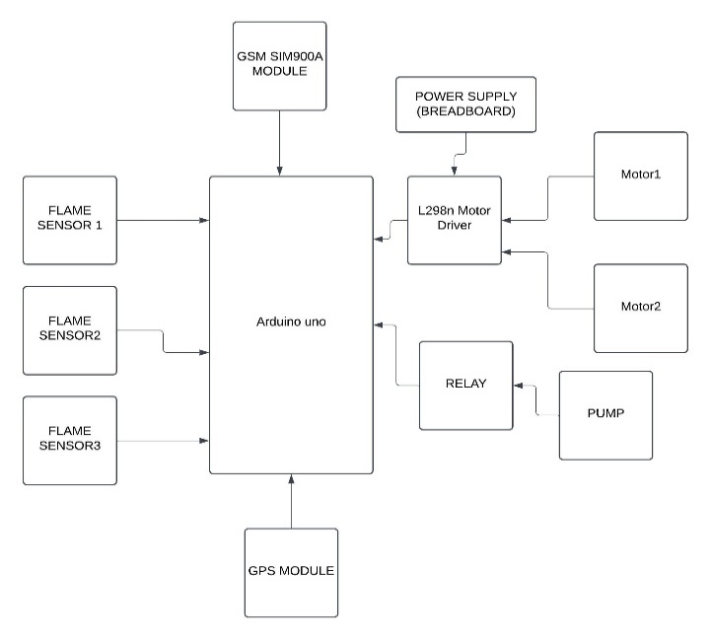

Figure 2: Flowchart of Robot

**Installation of Sensor:** Sensors should be installed in the most dangerous areas, considering factors like fire load and ventilation requirements. Ensure sensors are calibrated and maintained properly.

**Network Deployment:** Build a well-connected data transfer network between the sensors and the master control unit. Ensuring redundancy and fail-safe mechanisms are in place.

**Central Control Unit Setup:** Install the central control unit with appropriate software for configuration. Define alarm thresholds and establish response protocols.

**Response System Integration:** Integrate fire suppression, evacuation, and notification systems with the central control unit. Regularly testing and maintaining these systems to ensure functionality.

**Human Training:** Train personnel in system operations, emergency response procedures, and evacuation protocols. Conduct periodic drills to maintain readiness.

### Manual Mode

After approaching the fire, the Extinguishing Mechanism Module is deployed. A fluid delivery system**.** Protective fire hazard management system is a chain of modules, covering specific information of detection, navigation, and extinguishing and notification devices for the prevention of fire hazard. The Sensor Module is the heart of the system, which monitors the environment through flame, smoke, and temperature sensors for various conditions. The fire detection sensors measure values such as infrared radiation, smoke density, or temperature levels to detect fire-related anomalies, and transmit this data to the Control Module [7]. The Control Module (an Arduino microcontroller) takes inputs from the various sensors, and executes decision logic, determining whether a fire hazard exists based on thresholds.

Once a fire is confirmed, the Control Module activates the Navigation Module to determine and approach the source of the fire. The Navigation Module uses ultrasonic sensors to avoid obstacles, GPS modules to get location services and compute optimal paths using algorithms such as a star. This guarantees that the system can navigate to the hazard efficiently, avoiding obstacles and minimising response times. Motors and drivers facilitate movement of the system, while real-time adjustments allow for responsive navigation of the system in real-world, dynamic environments.

System, e.g. water pump or CO₂ dispenser, regulated by relays and actuators. Servo motors allow the extinguishing nozzle to point at the fire, while the pump or dispenser delivers the extinguishing agent. The suppression then continues until the fire is verified to have been extinguished, based on feedback from a sensor, ensuring that resources are used efficiently while also being effective in controlling the fire.

At the same time, the Communication Module improves situational awareness by alerting stakeholders to the incident. The system is integrated with an L298N for Wi-Fi connectivity and a GSM module for SMS capabilities to send real-time alerts with the GPS location of the fire and its status. IOT Powered Notifications allow for remote tracking and fast decision-making which is very important in unmanned or hard to reach places. In addition, the module is connected with IoT platforms for cloud-based monitoring, giving a holistic overview of the operation of the system.

Ultimately, through a modular system architecture, an effective resolution to fire hazards is sustained across the system in a collaborative and cohesive manner. With the combination of real-time sensing, intelligent navigation, targeted suppression, and robust communication, this autonomous framework can decrease risks and damage to the environment while promoting fire safety.

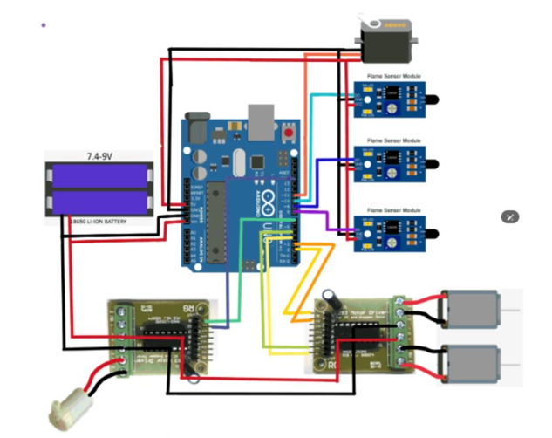

Figure 3. Simulation Diagram

Figure 3 shows the fire hazards pose a significant threat to life, property, and the environment. Proactive disaster management systems aim to mitigate these risks by early detection, rapid response, and effective control measures. This document outlines the design and implementation of a proactive fire hazard management system, incorporating advanced technologies and strategies

Bluetooth module is embedded in this is system to operate the robot from remote location in wireless mode. Version 2.0 Bluetooth protocol is used to communicate between robot and the remote. Bluetooth transceiver module is used as UART RS232 serial convertor module [3]. The module will operate between an input voltage of 3.3V to 6V. The Tx and Rx lines operate at 3.3V. It supports serial speed from 1200 to 1382400 bps (default is 9600 bps) and have 8 data bits, 1 stop bit, and do not have parity. The Bluetooth module has a range of 30m and working frequency of 2.4GHz to 2.524GHz. mobile phones with installed app can be used as remote control. By paring with module via Bluetooth [11]. This eliminates the need for development of a separate remote control module. The robot movement is controlled by two motors. When the flame sensor detects the fire location, the motors will be activated and moves the robot in the direction of fire. Motor Driver IC’s act as an interface between the microcontroller and the motors of the robot. Motor Driver IC L298N is a dual H bridge driver [12]. They act as a current amplifier since they take low current control signal and provide high current signal. High current signal is used to drive the motor. This IC contains two in-built H bridge driver circuits. In its common mode of operation, it can drive two DC motor simultaneously both in forward and reverse direction. The motor operations of two motors can be controlled by input logic at the input pins. 00 and 11 will cause the corresponding motor stop. 01 and 10 will rotate motor in clockwise and anticlockwise direction. The enable pins corresponding to each motor should be high to start the operation. When an enable pin is HIGH, the associated driver gets enabled. As a result, the outputs became active and work in phase

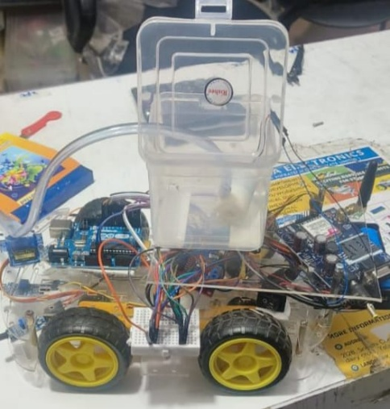

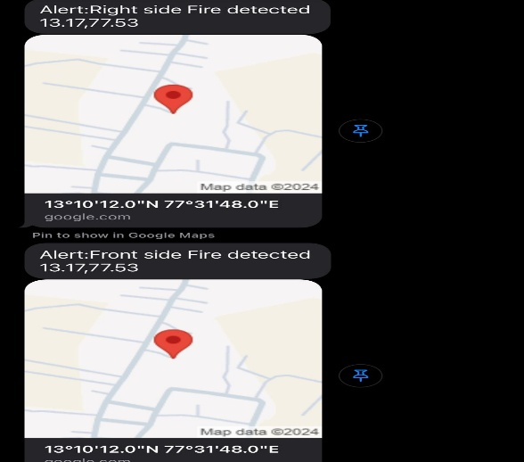

## Outcome And OutputDiagram

Fig 4: Development photo of the front view

## IV.CONCLUSION

This project represents an innovative step forward in fire safety technology, creating a Protective Fire Hazard Management System using Arduino. The system offers a complete solution for fire hazards in residential, industries and remote areas by combining sensor-based detection, autonomous navigation, efficient extinguishing, and real-time communication.

It makes early detection of fire-related anomalies possible so that damage and risk can be minimized by a rapid response. The Control Module reads sensor data and coordinates the actions of the system components to operate safely and efficiently. Adding a Navigation Module with the pathfinding algorithm, it has gained more mobility, enabling the system to find and reach fire hazards even in the complex workspace. The Extinguishing Mechanism Module guarantees efficient and effective fire suppression at the source, whereas the Communication Module provides real-time alerts and location tracking via GPS, enabling stakeholders to make timely and informed decisions.

By not including people, response times, and consequences, this modular and autonomous approach would undoubtedly assist with fire safety. Moreover, the incorporation of IoT components like the L298N and GSM module also provides guaranteed scalability and compatibility with current monitoring systems, making it appropriate for multiple purposes.

Finally, this system demonstrates an integration of automation, robotics, and IoT concepts to solve the main problem identified in case of fire hazard. This is definitely an innovative solution, and with further refinement and field testing, it could well become the benchmark for proactive, efficient, and reliable fire safety systems, helping to make our living and working environments safer.

REFERENCES

[1] Undug, J., Arabiran, M.P., Frades, J.R., Mazo, J., Teogangco, M., “Fire Locator, Detector and Extinguisher Robot with SMS Capability,” IEEE International Conference on Humanoid, Nanotechnology, Information Technology, Communication and Control, Environment and Management (HNICEM), Dec 2015.

[2] Luo, R.C., Lin, T.Y., and Su, K.L., “Multisensor Based Security Robot System for Intelligent Buildings,” Robotics and Autonomous Systems, vol. 57, no. 3, pp. 330-338, March 2009.

[3] White, W.R., “Vehicle Mounted Firefighting System,” U.S. Patent No. 5,836,398, Nov 1998.

[4] R. Luo, T. Lin, and K. Su, “Multisensor-based security robot system for intelligent building,” *Robotics and Autonomous Systems*, vol. 57, no. 3, pp. 268–279, Mar. 2009.

[5] W. R. White, “Vehicle mounted firefighting system,” U.S. Patent 5,836,398, Nov. 17, 1998.

[6] P. E. Hart, N. J. Nilsson, and B. Raphael, “A formal basis for the heuristic determination of minimum cost paths,” *IEEE Transactions on Systems Science and Cybernetics*, vol. 4, no. 2, pp. 100–107, July 1968.

[7] J. Undug, M. P. Arabiran, J. R. Frades, J. Mazo, and M. Teogangco, “Fire locator, detector and extinguisher robot with SMS capability,” in *Proc. 8th IEEE Int. Conf. Humanoid, Nanotechnology, Information Technology, Communication and Control, Environment and Management (HNICEM)*, Cebu City, Philippines, 2015, pp. 1–6.